Installing NodeMcu ESP8266 Libraries.

• Firstly,open the Arduino software

• Go to the file menu and click on the preferences.

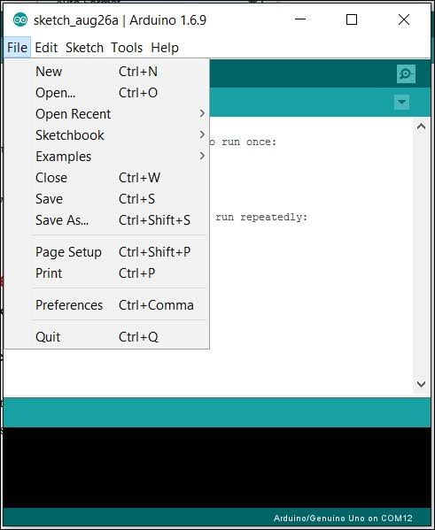

• Now and paste the URL link click okay on it.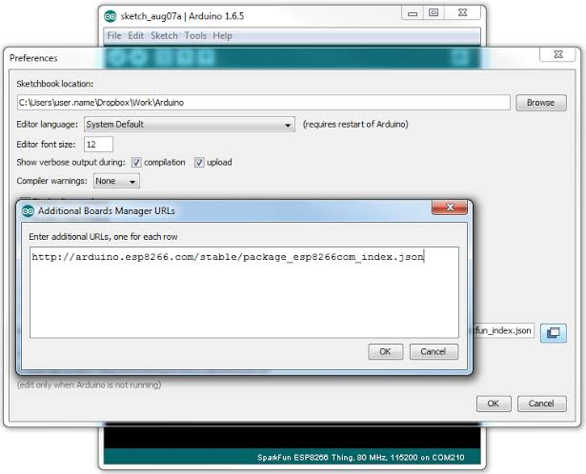

• Now go to the two weeks menu and click

on get Arduino.

• Now select the board manager and open it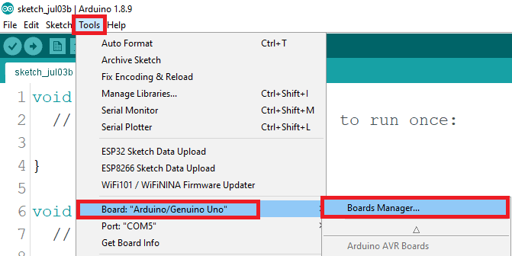

• In search option, type ESP8266 and click install option.

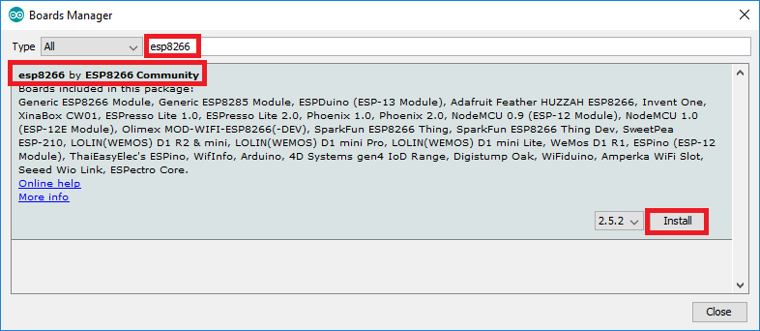

• After Installation, once again go to the board manager and we can see the ESP8266 libraries in the list.